**DSA practice problems**

**1.**Given a string **s** consisting of **lowercase**Latin Letters. Return the first **non-repeating character** in **s**. If there is no non-repeating character, return **'$'.**  
Note:When you return '$' driver code will output -1.

**Examples:**

**Input:** s = "geeksforgeeks"

**Output:** 'f'

**Explanation:** In the given string, 'f' is the first character in the string which does not repeat.

**Input:** s = "racecar"  
**Output:** 'e'  
**Explanation:** In the given string, 'e' is the only character in the string which does not repeat.

**Input:** s = "aabbccc"  
**Output:** '$'  
**Explanation:** All the characters in the given string are repeating.

**Code**

class Solution {

// Function to find the first non-repeating character in a string.

static char nonRepeatingChar(String s) {

// Create an array to store the count of each character

int[] count = new int[26];

for (char c : s.toCharArray()) {

count[c - 'a']++;

}

for (char c : s.toCharArray()) {

if (count[c - 'a'] == 1) {

return c;

}

}

return '$';

}

}

**Output:**

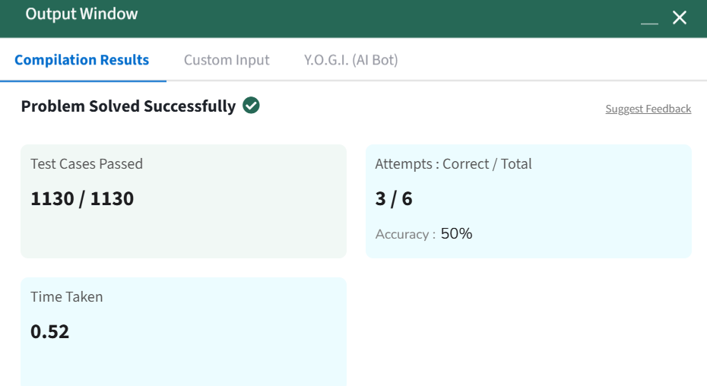

TIME COMPLEXITY : O(n)

SPACE COMPLEXITY : O(1)

**2.** **Given an array, arr[]. Sort the array using bubble sort algorithm.**

**Examples :**

**Input: arr[] = [4, 1, 3, 9, 7]**

**Output: [1, 3, 4, 7, 9]**

**Input: arr[] = [10, 9, 8, 7, 6, 5, 4, 3, 2, 1]**

**Output: [1, 2, 3, 4, 5, 6, 7, 8, 9, 10]**

**Input: arr[] = [1, 2, 3, 4, 5]**

**Output: [1, 2, 3, 4, 5]  
Explanation: An array that is already sorted should remain unchanged after applying bubble sort.**

**Constraints:  
1 <= arr.size() <= 103  
1 <= arr[i] <= 103**

**Code:**

class Solution {

// Function to sort the array using bubble sort algorithm.

public static void bubbleSort(int arr[]) {

int n = arr.length;

for(int j=0;j<n;j++){

for(int i=0;i<n-1;i++){

if(arr[i]>arr[i+1]){

int temp = arr[i];

arr[i] = arr[i+1];

arr[i+1] = temp;

}

}

}

}

}

**Output:**



**Time Complexity: O(n log n)**

**Auxiliary Space: O(1)**

**3.** Implement **Quick Sort**, a Divide and Conquer algorithm, to sort an array, arr[] in ascending order. Given an array, arr[], with starting index low and ending index high, complete the functions partition() and quickSort(). Use the last element as the pivot so that all elements less than or equal to the pivot come before it, and elements greater than the pivot follow it.

Note: The low and high are inclusive.

Examples:

Input: arr[] = [4, 1, 3, 9, 7]

Output: [1, 3, 4, 7, 9]  
Explanation: After sorting, all elements are arranged in ascending order.

Input: arr[] = [2, 1, 6, 10, 4, 1, 3, 9, 7]

Output: [1, 1, 2, 3, 4, 6, 7, 9, 10]  
Explanation: Duplicate elements (1) are retained in sorted order.

Input: arr[] = [5, 5, 5, 5]

Output: [5, 5, 5, 5]  
Explanation: All elements are identical, so the array remains unchanged.

Constraints:  
1 <= arr.size() <= 103  
1 <= arr[i] <= 104

**Code:**

class Solution {

static void quickSort(int arr[], int low, int high) {

if(low<high){

int pi = partition(arr,low,high);

quickSort(arr,low,pi-1);

quickSort(arr,pi+1,high);

}

}

static int partition(int arr[], int low, int high) {

int pivot = arr[high];

int i = low - 1;

for (int j = low; j <= high - 1; j++) {

if (arr[j] < pivot) {

i++;

swap(arr, i, j);

}

}

swap(arr, i + 1, high);

return i + 1;

}

static void swap(int[] arr, int i, int j) {

int temp = arr[i];

arr[i] = arr[j];

arr[j] = temp;

}

}

**Output:**

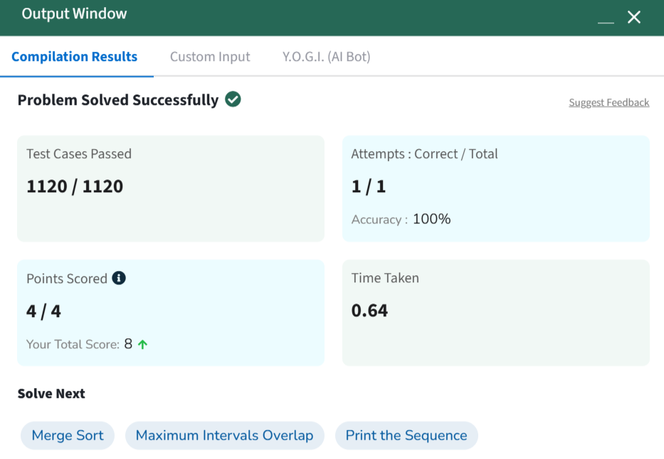

TIME COMPLEXITY : O(nlogn)

SPACE COMPLEXITY : O(logn)

**4.** Given an array **arr[]** of positive integers and an integer **k**, Your task is to return **k largest elements**in decreasing order.

**Examples**

**Input:** arr[] = [12, 5, 787, 1, 23], k = 2

**Output:** [787, 23]

**Explanation:** 1st largest element in the array is 787 and second largest is 23.

**Input:** arr[] = [1, 23, 12, 9, 30, 2, 50], k = 3

**Output:** [50, 30, 23]

**Explanation:** Three Largest elements in the array are 50, 30 and 23.

**Input:** arr[] = [12, 23], k = 1

**Output:** [23]

**Explanation:** 1st Largest element in the array is 23.

**Constraints:**  
1 ≤ k ≤ arr.size() ≤ 106  
1 ≤ arr[i] ≤ 106

**Code:**

class Solution {

static List<Integer> kLargest(int arr[], int k) {

List<Integer> l = new ArrayList<>();

Arrays.sort(arr);

for(int i = arr.length - 1 ; i>arr.length -1 -k ; i--){

l.add(arr[i]);

}

return l;

}

}

**Output:**

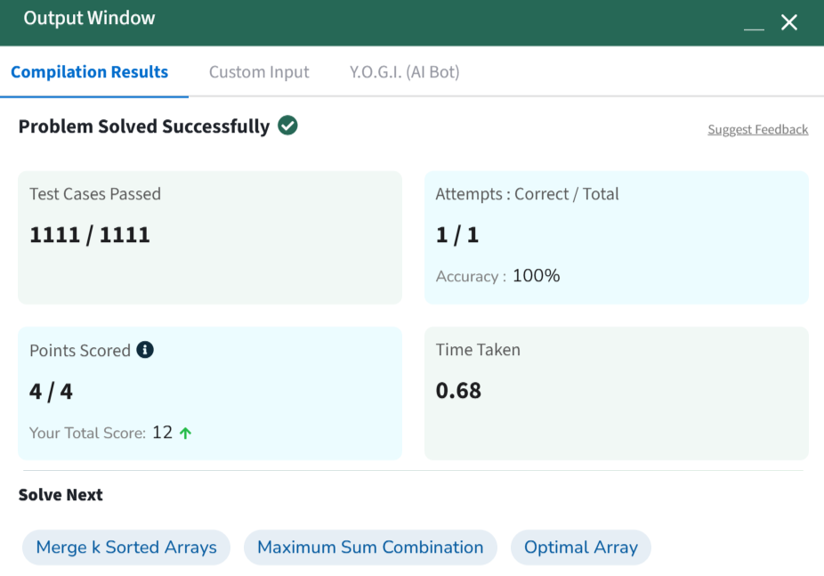 TIME COMPLEXITY : O(nlogn)

SPACE COMPLEXITY : O(n)

**5.** Given two strings **s1** and **s2.**Return the minimum number of operations required to convert **s1**to **s2**.  
The possible operations are permitted:

1. Insert a character at any position of the string.
2. Remove any character from the string.
3. Replace any character from the string with any other character.

**Examples:**

**Input:** s1 = "geek", s2 = "gesek"

**Output:** 1

**Explanation:** One operation is required, inserting 's' between two 'e'.

**Input :** s1 = "gfg", s2 = "gfg"

**Output:** 0

**Explanation:** Both strings are same.

**Input :** s1 = "abc", s2 = "def"

**Output:** 3

**Explanation:** All characters need to be replaced to convert str1 to str2, requiring 3 replacement operations.

**Constraints:**  
1 ≤ s1.length(), s2.length() ≤ 500  
both the strings are in lowercase.

Try more examples

**Code:**

class Solution {

public int editDistance(String str1, String str2) {

int m = str1.length();

int n = str2.length();

int[][] dp = new int[m+1][n+1];

for(int i=0;i<=m;i++)

dp[i][0] = i;

for(int j=0;j<=n;j++)

dp[0][j] = j;

for(int i=1;i<=m;i++){

for(int j=1;j<=n;j++){

if(str1.charAt(i-1)==str2.charAt(j-1))

dp[i][j] = dp[i-1][j-1];

else

dp[i][j] = Math.min(dp[i-1][j],Math.min(dp[i][j-1],dp[i-1][j-1]))+1;

}

}

return dp[m][n];

}

}

**Output:**

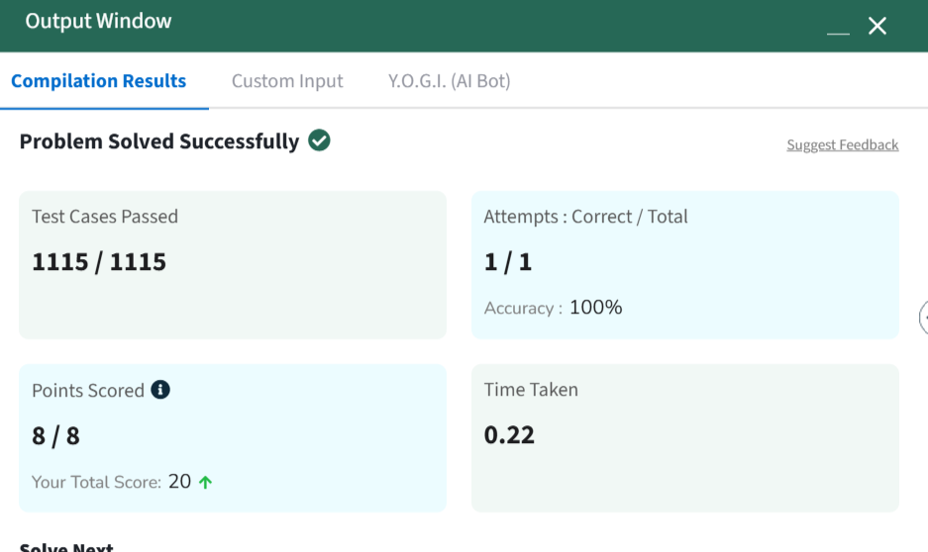 TIME COMPLEXITY : O(m*n)

SPACE COMPLEXITY : O(m*n)

**6. Given an array of integers arr[] representing non-negative integers, arrange them so that after concatenating all of them in order, it results in the largest possible number. Since the result may be very large, return it as a string.**

**Examples:**

**Input: arr[] = [3, 30, 34, 5, 9]**

**Output: "9534330"**

**Explanation: Given numbers are {3, 30, 34, 5, 9}, the arrangement "9534330" gives the largest value.**

**Input: arr[] = [54, 546, 548, 60]**

**Output: "6054854654"**

**Explanation: Given numbers are {54, 546, 548, 60}, the arrangement "6054854654" gives the largest value.**

**Input: arr[] = [3, 4, 6, 5, 9]**

**Output: "96543"**

**Explanation: Given numbers are {3, 4, 6, 5, 9}, the arrangement "96543" gives the largest value.**

**Constraints:  
1 ≤ arr.size() ≤ 105  
0 ≤ arr[i] ≤ 105  
The sum of all the elements of the array is greater than 0.**

**Code:**

class Solution {

String printLargest(int[] array) {

String[] arr = new String[array.length];

for(int i = 0 ; i<array.length ; i++){

arr[i] = Integer.toString(array[i]);

}

Arrays.sort(arr, (a, b) -> (b + a).compareTo(a + b));

if (arr[0]=="0"){

return "0";

}

StringBuilder result = new StringBuilder();

for (String numStr : arr) {

result.append(numStr);

}

return result.toString();

}

}

**Output:**

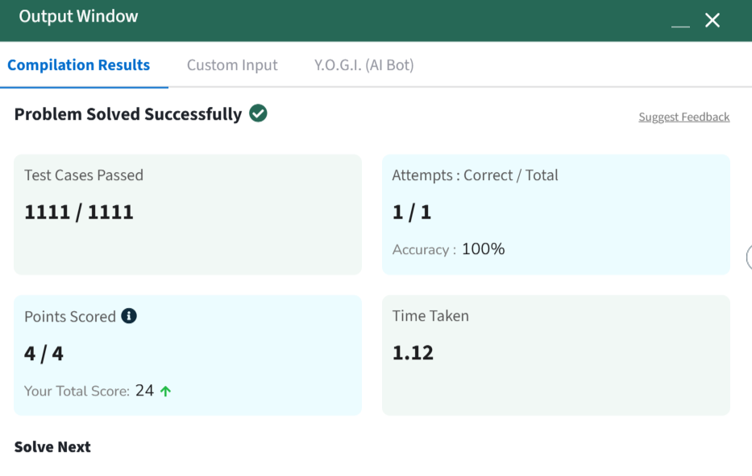

TIME COMPLEXITY : O(nlogn * m)

SPACE COMPLEXITY : O(n)